CONTACT INFORMATION:

Minister: Pastor Paul Tompkins
Mobile:07968 388 085
e-mail: paul@adventist.scot

Elders:
Mrs E Dutton 01764 654590
Mrs S Froude 01764 670003
Pastor D Hatch 07878532788
Mr S Peacock 01764 681348
Mr K Thompson 01764 655032
Pastor P Tompkins 01764 650090

Lead elder for July: Mrs Eleri Dutton

CHURCH WEBSITE:
For information on what is happening in our church, please visit the website on www.crieffadventist.org.uk

CHURCH BULLETIN:
Any items for the church bulletin should be given to Sheila Sinclair by 6.00 p.m. Tuesday.
Telephone: 01764 654797
E-mail: bulletin@crieffadventist.org.uk

PREACHING PLAN:

July 21 Pastor Doug Sinclair
July 28 Pastor Bob Rodd

SUNSET TIMES FOR CRIEFF

Today: 9:53 pm
Next Friday 20 July 9:45 pm

Welcome to Crieff
Seventh-day Adventist Church

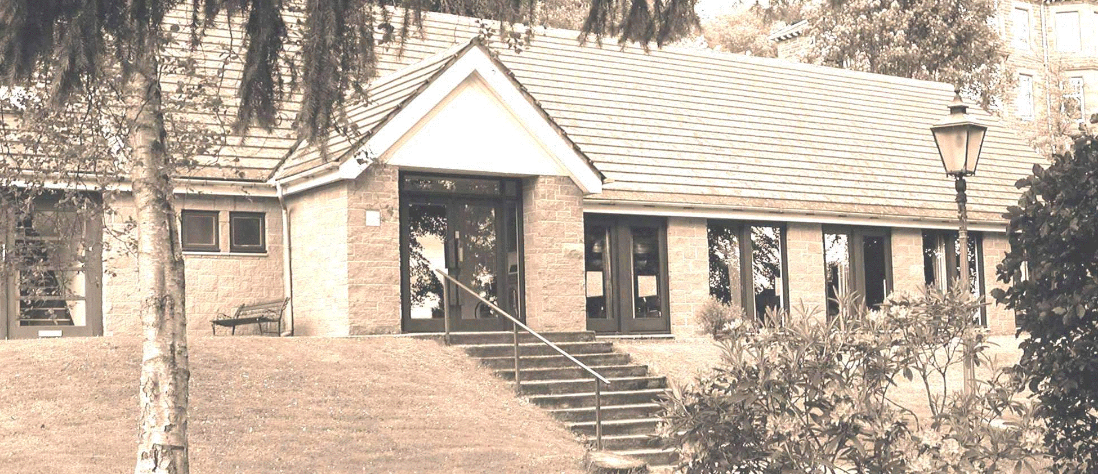
WORSHIP SERVICE
14 July 2018
11:20 a.m.

Welcome

Call to Worship: Psalm 47

Hymn: NAH 14 All things Praise Thee

Scripture: Psalm 29

Prayer

Tithes and Offerings

Children’s Story

Hymn: NAH 28 Lord God Omnipotent

Sermon: “Who Is God?

Hymn: NAH 592 Joyful, Joyful, We Adore Thee

Benediction

Organ Meditation
WELCOME – We are so pleased that you are able to join us for our worship service today. We welcome Mr Keith Thompson to the pulpit this morning. Let us remember the Lord’s presence is in this place, so be reverent before Him and receive His blessings.

TODAY’S SERMON
If you would like a copy of today’s sermon on CD, please leave a note of your name and today’s date in the Sermon Tapes Box as you leave the church. Contributions of £1 per CD would be appreciated. Excess funds from production go to CAP funds.

MORE ABOUT OUR CHURCH
Would you like to know more about our church, would you like to develop your relationship with God, or prepare for baptism? Do you know of someone who would appreciate a visit, or is unwell? If so, please speak with the Minister or one of the church Elders.

SABBATH SERVICES
Prayer Group 9.30 a.m.
Song Service 9.45 a.m.
Sabbath School 10.00 a.m.
Worship Service 11.20 a.m.

REFRESHMENTS -
All are invited to enjoy refreshments in the church hall between Sabbath School and the Worship service, and after the Worship service, leaving the church as a quiet space for prayer and reflection.
BRING-AND-SHARE FELLOWSHIP LUNCH – in the Ross Hall after the Worship Service. All visitors are most welcome to share in this meal.

PRAYER CHAIN - Please telephone Morag Galloway on 01764 660769 if you have any prayer requests you would like to share with the church.
PRAYER FOCUS FOR CRIEFF AID PROJECTS - Please remember the CAP river boat ambulance project in your prayers this week.

PRAYER FOR STRATHEARN is taking a break over the summer. The next meeting will take place on 14 September at 7.00 p.m. in our church.

FINLAY’S ROMANIAN QUEST – Please would you help by sharing the following link with all your friends and acquaintances? We would like to spread the fundraising net as widely as possible:
httpsw.gofundme.com/finlay039s-romanian-quest
Finlay’s Romanian Quest has raised £1,594 so far. More fundraising projects are planned for August and September.

CRIEFF CHURCH OFFERINGS - JUNE
Tithe: 4,317.00
Sabbath School: 406.00
CAP: 177.00
Budget: 449.00

CHILDREN’S LENDING LIBRARY – books will be on the table in the foyer after the worship service for children to read and return to Liana. Any books you have at home, which you could make available for the children’s library, would be much appreciated.

SMART LOVE – a one-day seminar will be held at Dundee SDA church on Sunday, 22nd July from 10.00-15.00. Free lunch will be provided, and children will be catered for while parents attend Seminar.
“Smart Love” is a programme designed to educate our young people about decisions they will need to make from a Christian perspective – how to appreciate who they are, and help with decisions about dating, etc. See poster on notice board for further details.

PETER THIRKELL – it is with great sadness that we announce the death of Peter Thirkell on Sunday, 8th July. Our thoughts and prayers are with Audrey, and her daughters, Lynne, Beverley and Dawn, and their families. A Service of Thanksgiving for the life of Peter will be held at 2.00 p.m. on Wednesday, 18 July, at our church.

